* Off-Lab
* Part 1
  + Code for DTLTI function

function [y]= DTLTI(a,b,x,Ny)

y=zeros(1,Ny);

Nx = length(x);

for n = 0:Ny-1

for l = 1:length(a)

if n + 1 - l > 0

y(n + 1)=y(n + 1)+a(l)\*y(n + 1-l);

end

end

for k = 1:length(b)

if n + 1 - (k-1) > 0 && n + 1 - (k-1) <= Nx

y(n + 1)=y(n + 1)+b(k)\*x(n +1 -(k-1));

end

end

end

* Part2
  + The impulse response code and plotA screenshot of a cell phone

    Description automatically generated

D5=mod(21703374,5);

a=0;

M=3+D5;

k=[0:M-1];

b=exp(-k / 3);

x=1;

n=[0:10];

Ny=length(n);

y=DTLTI(a,b,x,Ny);

stem(n,y, 'fill', 'Color', 'k');

title('Impulse Response for a = 0 b = e^{-k/3}');

xlabel('n');

ylabel('h[n]');

* + The magnitude response of the DTFT and the 3dB bandwidth

omega = -pi:0.001:pi;

H = 0;

for k = 0:6

H = H + exp(-k \* (j \* omega + 1/3));

end

subplot(2,1,1)

plot(omega, abs(H),'-k');

title('Fourier Transform of Impulse Response');

xlabel('œâ');

ylabel('|H(e^{jœâ})|');

%gain

subplot(2,1,2)

gain = 20 \* log10(abs(H));

plot(omega/(2 \* pi), gain,'-k');

ylim([(max(gain) - 3) (max(gain) )]);

title('The Gain of H(e^{jœâ})');

xlabel('f');

ylabel('dB');

* + Discreet Time Chirp Signal and frequency behavior for different L values

L = [256 128 512];

for i = 1:3

n = [0:L(i) - 1];

func = exp(j \* (pi / L(i)) \* n.^2 );

y = DTLTI(a, b, func, length(n));

xaxis = linspace(0, 2 \* pi, L(i));

subplot(3,2,(2 \* i - 1));

plot(xaxis, abs(y));

xlim([0 2\*pi]);

title(['Discreet - Time Chirp, Magnitude, L = ' num2str(L(i)) ]);

xlabel('œâ');

ylabel('|Y(e^{jœâ}|');

subplot(3,2,(2 \* i));

plot(xaxis, angle(y));

xlim([0 2\*pi]);

title(['Discreet - Time Chirp, Phase, L = ' num2str(L(i)) ]);

xlabel('œâ');

ylabel('phase of Y');

end

* Part 3
  + A close up of a map

    Description automatically generatedMagnitude Response of filter

p1=(4+j\*10)/((117)^(0.5));

p2=(5+j\*9)/((107)^(0.5));

z1=(3+j\*7)/((58)^(0.5));

figure(4);

omega = [0:0.001:2\*pi];

filt = (exp(j .\* omega) - z1)./((exp(j .\* omega) - p1) .\* (exp(j .\* omega) - p2));

plot(omega ,abs(filt))

xlabel('œâ')

ylabel('|H(e^{jœâ})|')

title('The Magnitude Response');

a = [(p1 + p2) (-p1 \* p2)];

b = [1 -z1];

* + The Chirp signal and the frequency behavior

a = [(p1 + p2) (-p1 \* p2)];

b = [1 -z1];

figure(5);

L = [256 128 512 2^20];

for i = 1:4

if (i == 4)

figure(6);

n = [0:L(i) - 1];

func = exp(j \* (pi / L(i)) \* n.^2 );

y = DTLTI(a, b, func, length(n));

xaxis = linspace(0, 2 \* pi, L(i));

subplot(2,1,1);

plot(xaxis, abs(y));

xlim([0 2\*pi]);

title(['Discreet - Time Chirp, Magnitude, L = ' num2str(L(i)) ]);

xlabel('œâ');

ylabel('|Y(e^{jœâ}|');

subplot(2,1,2);

plot(xaxis, angle(y));

xlim([0 2\*pi]);

title(['Discreet - Time Chirp, Phase, L = ' num2str(L(i)) ]);

xlabel('œâ');

ylabel('phase of Y');

else

n = [0:L(i) - 1];

func = exp(j \* (pi / L(i)) \* n.^2 );

y = DTLTI(a, b, func, length(n));

xaxis = linspace(0, 2 \* pi, L(i));

subplot(3,2,(2 \* i - 1));

plot(xaxis, abs(y));

xlim([0 2\*pi]);

title(['Discreet - Time Chirp, Magnitude, L = ' num2str(L(i)) ]);

xlabel('œâ');

ylabel('|Y(e^{jœâ}|');

subplot(3,2,(2 \* i));

plot(xaxis, angle(y));

xlim([0 2\*pi]);

title(['Discreet - Time Chirp, Phase, L = ' num2str(L(i)) ]);

xlabel('œâ');

ylabel('phase of Y');

end

end

* + At L = 2^20, the frequency behavior is exactly the same as the magnitude response

* On-Lab

wc = pi/3;

alpha = (1 - sin(wc))/ cos(wc);

a = alpha;

b = (1 - alpha) / 2;

n=[0:10];

x = 1;

h = DTLTI(a, [b b] , x, length(n));

stem(n, h, 'fill' ,'Color', 'k');

figure(2);

n = [0:4095];

x = cos( fix(n /32) \* pi ./127 .\* n);

h = DTLTI(a, [b b] , x, length(n));

stem(n, h, 'Color', 'r');

xlim([0 4200]);

* + Graph of the impulse response

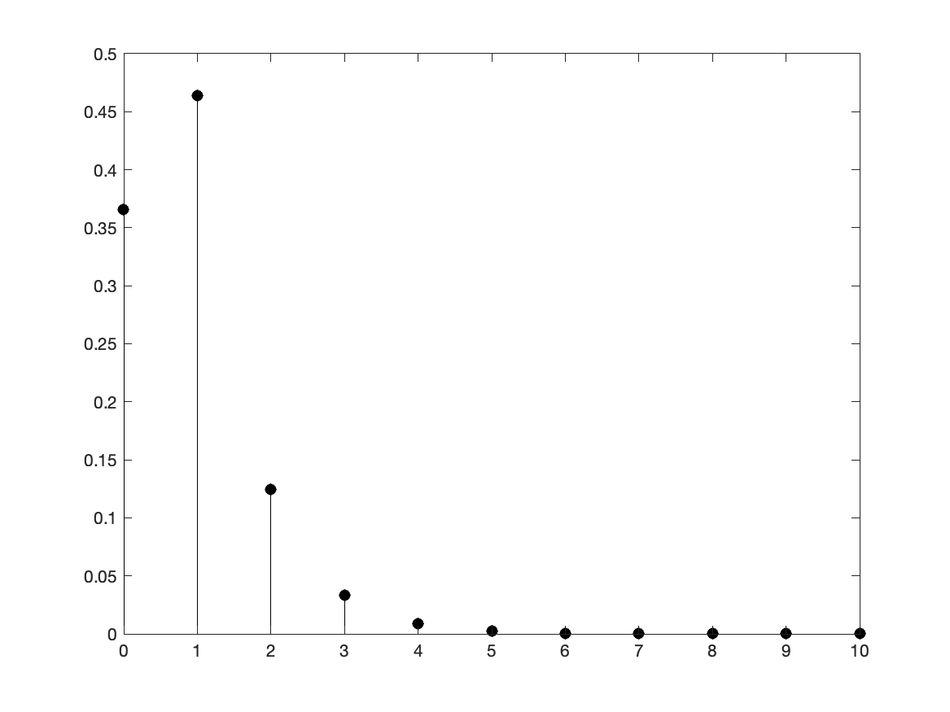

* + Graph of the define function

